Grade 3: Addition
Strategy: Partial Sums
Each addend is broken apart by place value, each place value is added and then the partial sums and added.
Example:
248 + 345=

200+300=500
40+40=80
8+5=13
500+80+13=593

Strategy: Adjusting
Value from one addend is given to the other addend to create an easier problem.
326 + 274
-1 +1
325 + 275 =500

Strategy: Number Line and Adjusting
The number line breaks the addend into smaller chunks and demonstrates calculations that the student can solve mentally.
516+179=
+100 +80 -1 =179

516 616 696
695

Strategy: Subtraction
Count Up or Count Down on a Number Line
536-179

+21 +300 +36
179 200 500 536
300+21+36=357

-21 -300 -36
179 200 500 536

Strategy: Use friendly number to make it easier to solve mentally.
4,000 - 563 =
-1 -1
3,999 - 542 =

The difference is the same, but easier to solve by subtracting each place value.
3999
- 542
3457

Multiplication
In Third grade students develop an understanding of multiple representations of the same value. They can look at 4X8 in many different ways.

Repeated Addition
8+8+8+8
4+4+4+4+4+4+4+4
Sets
4 groups of 8

Each 4 octagons have 8 sides= 32 sides
9 groups of 4

Each 8 squares have 4 sides = 32 sides
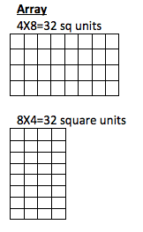

Array/Area Model
The array model (squares showing) and the area model (squares not showing) for multiplication and the distributive property are used to solve multiplication problems.
Array Model for 8X7
X 5 + 2
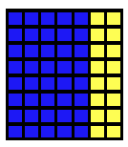
8
(8X5) (8X2)
Area Model for 8X7
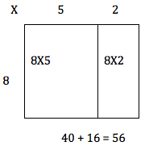

Students move from the array model to working with partial products.
8X7
7=5+2
(8X5) + (8X2) = 40 + 16 = 56

Multiply by powers of 10

3X1=3 3X4=12
3X1 ten = 3 tens 3X4 tens = 12 tens
3 X 10 = 30 3X40=120
Strategy:
Strategy: Doubling and Halving
If you half one factor and double the other factor your product is the same.

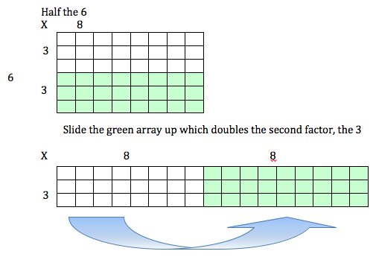
For 6X8 you will take half of 6 and double the 8 leaving an array that is 6X8=(3X8)+(3X8)

Division
Connect division to basic multiplication facts.
3X4 = 12 12 ÷4 = n
Think 4 times what equals 12.
Equal Shares
How many times can I make 4 equal groups if I start with 12 objects?
4 Cubes
4 Cubes
4 Cubes

12-4=8 8-4=4 4-4=0 cubes left.
You can make 3 equal groups.
OR
How many will fit in 4 different cups is I start with 12 objects?
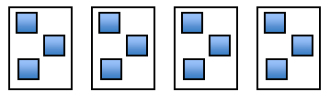
There are 3 objects in each cup.

GRADE 3
CUTE PHOTO

HCPSS.ORG

STRATEGIES FOR COMPUTATION

Goal: students should move towards efficiency, choosing a strategy that solves the problem quickly and accurately and one that they can explain.

